Dette øvelses sæt er bygget op om en række spørgsmål på w3ressource.com

<https://www.w3resource.com/csharp-exercises/>

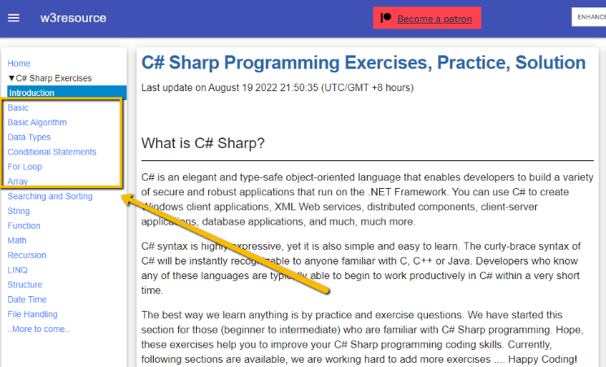I dette materiale finder du udvalgte opgaver i de viste kategorier, hvor kriteriet for udvælgelsen har været, at de skulle kunne gennemføres når du har set første sæt af Bob’s video casts.

Men ok, no guarantees given – i nogle tilfælde må man peeke i løsningen, for at blive hjulpet lidt på vej. Det vigtige i dette tilfælde er, at du rent faktisk selv taster løsningen ind: I kodeværktøjet vil du se feks autocompletion, så hvis du ikke taster selv, snyder du dig selv for den erfaring.

I enkelte tilfælde er der et par noter som du måske kan bruge.

Måske finder du selv opgaver i denne samling eller noget helt tredje, (når du selv tager på tur og googler hvad der findes af excesices – der er en del…) som du ønsker vi skal gennemgå, så lad mig høre om det.

Nummereringen i opgaverne matcher opgavenummeret på sitet.

# Basic Declarations and Expressions

<https://www.w3resource.com/csharp-exercises/basic/index.php>

Q05. Write a C# Sharp program to swap two numbers

Q06 6. Write a C# Sharp program to print the output of multiplication of three numbers which will be entered by the user

Q07 Write a C# Sharp program to print on screen the output of adding, subtracting, multiplying and dividing of two numbers which will be entered by the user

Q14. Write a C# program to convert from celsius degrees to Kelvin and Fahrenheit.

Q18 Write a C# program to check two given integers and return true if one is negative and one is positive

Q22. Write a C# program to check if an given integer is within 20 of 100 or 200

Q24. Write a C# program to find the longest word in a string

string line = "Write a C# Sharp Program to display the following pattern using the alphabet.";

string[] words = line.**Split**(new[] { " " }, StringSplitOptions.None);

Q34. Write a C# program to check if a string starts with a specified word.

Note: Suppose the sentence starts with "Hello"

Sample Data: string1 = "Hello how are you?"

Result: Hello.

# Data Types

<https://www.w3resource.com/csharp-exercises/data-types/index.php>

Q4. Write a C# Sharp program that takes two numbers as input and perform an operation (+,-,*,x,/) on them and displays the result of that operation.

Q5. Write a C# Sharp program that takes the radius of a circle as input and calculate the perimeter (omkreds) and area of the circle

O=2*PI*r, A=PI*r^2

Q6. Write a C# Sharp program to display certain values of the function x = y2 + 2y + 1 (using integer numbers for y , ranging from -5 to +5)

# Conditional Statement

<https://www.w3resource.com/csharp-exercises/conditional-statement/index.php>

Note: The if / else

Q01 Write a C# Sharp program to accept two integers and check whether they are equal or not.

Q02 Write a C# Sharp program to check whether a given number is even or odd

rem1 = num1 % 2;

Remainder operator %:The remainder operator % computes the remainder after dividing its left-hand operand by its right-hand operand.

Q03. Write a C# Sharp program to check whether a given number is positive or negative

Q04.Write a C# Sharp program to find whether a given year is a leap year or not

Q09. Write a C# Sharp program to accept a coordinate point in an XY coordinate system and determine in which quadrant the coordinate point lies

Q10 Write a C# Sharp program to find the eligibility of admission for a professional course based on the following criteria:

|  |  |
| --- | --- |
| Criteria | Marks in Maths >=65  Marks in Phy >=55  Marks in Chem>=50 |
| Rules | Total in all three subject >=180  or  Total in Math and Phy >=140 |
| Test Data | Input the marks obtained in Physics :65  Input the marks obtained in Chemistry :51  Input the marks obtained in Mathematics :72 |
| Expected Output : | The candidate is eligible for admission. |

# For-Loop

<https://www.w3resource.com/csharp-exercises/for-loop/index.php>

Q1. Write a program in C# Sharp to display the first 10 natural numbers

Q4 Write a program in C# Sharp to read 10 numbers from keyboard and find their sum and average

Q5. Write a program in C# Sharp to display the cube of the number up to given an integer. Go to the editor

Test Data :

Input number of terms : 5

Expected Output :

Number is : 1 and cube of the 1 is :1

Number is : 2 and cube of the 2 is :8

Number is : 3 and cube of the 3 is :27

Number is : 4 and cube of the 4 is :64

Number is : 5 and cube of the 5 is :125

Q6 Write a program in C# Sharp to display the multiplication table of a given integer.

Test Data : Input the number (Table to be calculated) : 15

Expected Output : 15 X 1 = 15 ... ... 15 X 10 = 150

Q9. Write a program in C# Sharp to display the pattern like right angle triangle using an asterisk. Go to the editor

The pattern like :

*

**

***

****

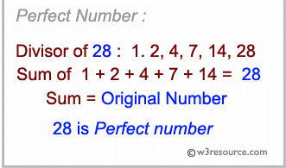27. Write a C# Sharp program to check whether a given number is perfect number or not

# Array

<https://www.w3resource.com/csharp-exercises/array/index.php#editorr>

Q3 Write a program in C# Sharp to find the sum of all elements of the array.

Q4. Write a program in C# Sharp to copy the elements one array into another array.

Q9. Write a program in C# Sharp to find maximum and minimum element in an array

Q10. Write a program in C# Sharp to separate odd and even integers in separate arrays

Q18. Write a program in C# Sharp for a 2D array of size 3x3 and print the matrix

# Basic Algorithm

<https://www.w3resource.com/csharp-exercises/basic-algo/index.php>

Q3. Write a C# Sharp program to check two given integers, and return true if one of them is 30 or if their sum is 30

Q10. Write a C# Sharp program to check if a given positive number is a multiple of 3 or a multiple of 7.